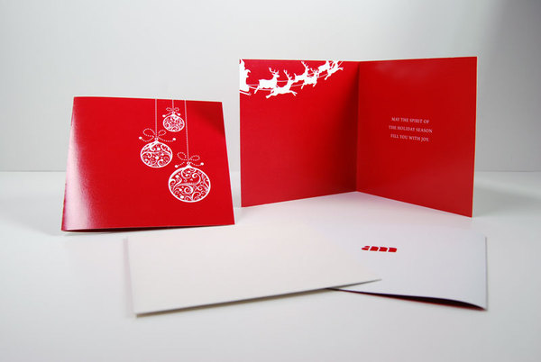

Greeting Card send to your family and friend in a different occassion.....

Product: CARD

Price:790.00 PKR

CONTACT US: Address: Aptech Metro StarGate Karachi

Phone.no: 03142191402

Email: feedback@aptech-educationcom.pk